Bandit level 8 to level 9
To login to the level 8 use the username as
Then use ls command to display the file.
And then use sort data.txt | uniq -u which is used to sort the contents of the file and display the lines which appears exactly once.
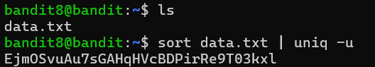
Finally you will get the password for level 9.

